Assignment 7
a)

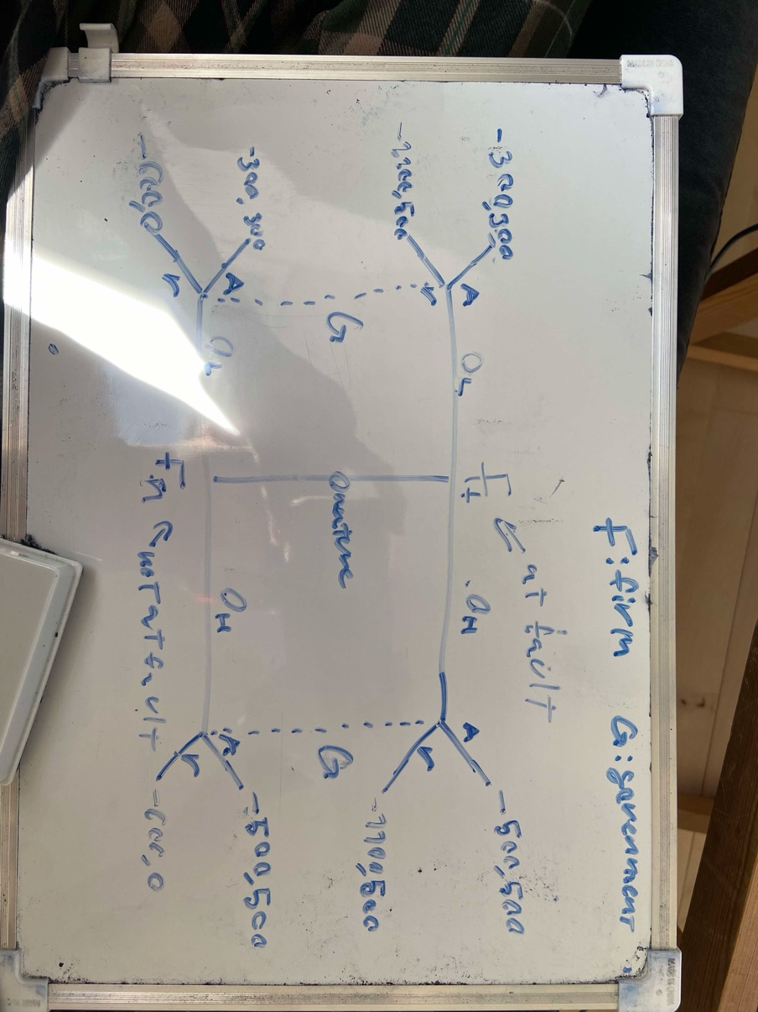
b)
we check each starting with split EQ:
$$\left(H,L\right)$$
We notice that G accepts the low offer in the not guilty state , this means that the ”at fault type will want to deviate to signal ”low bid” and recieve his lowets possible payoff being -300 thus this can never be an EQ

$$(L,H)$$
Given low bid G will reject
Given high bid G will accept
Giving us possible EQ $=\{\left(L,H\right),\left(r,a\right)\}$
In this EQ F prefers to place a high bid given faulty giving him payoff -500 instead of -1100
Thus this cannot be an eq

Pooling:
$$(H,H)$$
$μ_{H}=0.5$

$$G preffers A given H$$
For F not to deviate G must not play A given low thus we find $μ_{r}$ such that
$$E\left[u\left(A\right) | L\right]<E\left[u\left(R\right) | L\right]$$
$$μ_{r}·300+\left(1-μ_{r}\right)·300<500·μ_{r}$$
$$⇔\frac{3}{5}<μ_{r}$$
Thus we have a pooling EQ
$$σ^{⋆}=(\left(Fault→H,Not Fault→H\right),\left(H→A,L→R\right), for μ_{H}=\frac{1}{2},μ_{R}>\frac{3}{5})$$

$$(L,L)$$
$$μ_{R}=\frac{1}{2}$$
$$E\left[u\left(A\right) | L\right]=300$$
$$E\left[u\left(R\right) | L\right]=\frac{1}{2}·500=250$$
Thus $L→A$
F gets -300 in payoff in both cases which are both the lowest possible meaning F would never deviate

c) check the intuitive criterion
$$(L,L)$$
In either state F gets his lowest possible payoff meaning that he would never deviate satisfying the intuituve criterion

$$(\left(Fault→H,Not Fault→H\right),\left(H→A,L→R\right), for μ_{H}=\frac{1}{2},μ_{R}>\frac{3}{5})$$
Both faulty and not faulty player types can optain a larger payoff(given different moves by G) by deviating thus we can not set $μ_{R}$ to 0 or 1 as we would want to eliminate an EQ using the intuitive criterion

In conklusion:
The intuitive criterion removes no equilibria

